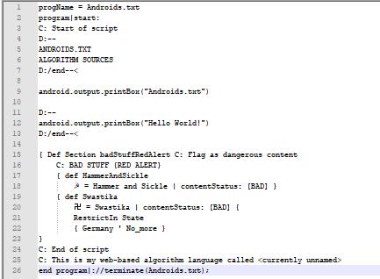

so what I have gotten for the syntax so far is this. It is based off 5 different languages:
* Python 3.x
* FORTRAN95
* Java 1.8
* Visual Basic
* HTML
The comment system is based off its own idea, except the D:-- is supposed to resemble the <!-- test comment !-→ in HTML. The C in C: stands for comment and the D in D: stands for dialog
the “def” stands for define. The curly braces are similar to Java. The print command is similar to Python but at the same time, very Java-like, based off the System.out.print or System.out.println commands. The end program|://terminate(Androids.txt); is meant to terminate (stop) the program. At the beginning, the program name is defined. It is defining a section of some symbols to restrict in some regions, but the regions haven’t been defined yet. The way the Define command is set up is similar to VBS and the start and terminate program features are similar to FORTRAN95. I don’t know what kind of language it is yet. I am just starting it. In this demonstration, you can see it blacklisting the communist symbol “hammer and sickle” and the Nazi Germany hate symbol “swastika” however it isn’t fully set up yet. I made it for fun. I might continue on it.

